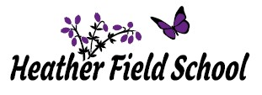

**Autumn Term 1 2024**

**Newsletter**

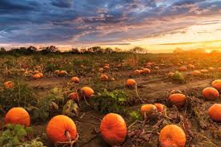



**Newsletter October 2024**

The start of this new academic year has been filled with lots of exciting and fun learning opportunities for our students. These have included celebrating International Charity Day, Democracy Day, Mental Health Awareness Day, World Food Day and FairTrade Fortnight to name a few!

I would like to take this opportunity to inform you of some changes to the Senior Leadership Team for this academic year. After the birth of her beautiful daughter, Jennifer Newton is now on maternity leave, which has resulted in Karl High being appointed as Acting Deputy Head Teacher. We have also increased the capacity of the leadership team through the addition of Matthew Lawrence, who has joined Heather Field as a Deputy Head Teacher. Matthew has made a great start to his new role and is already building fantastic relationships with all pupils and staff. Gary Cornwell (Assistant Head Teacher) and Tarnya Tokeley (Assistant Head Teacher) also remain ever present and essential members of the Senior Leadership Team for the 2024-25 Academic Year.

As many of you are aware, we have been having some building work completed over the last few months, on a pre-existing derelict building on our site. I am happy to report that the work on this building is nearly finished and it is looking fantastic! This building includes a community room, which we are looking forward to using for future community events, such as, bake sales and coffee mornings. Over the half term holiday, we will also be completing some renovation work on our car park, which will result in additional car parking spaces, as well as a new pedestrian gate. This gate and the addition of a new bike shed, is our proactive response to a number of pupils and staff who now choose to walk or cycle to school. All of the essential work that we have carried out will hopefully result in a smooth and successful transition, for when we carry out our intention, to increase the number of pupils that we have at the school.

As we approach the completion of the first half-term, I would like to thank all parents / carers for your continuous unwavering support. The IEP open day and the first coffee morning have resulted in us being able to meet with parents and carers. At Heather Field School we are a family and the triangulation of support between pupils, staff and parents / carers will ensure that all of our pupils flourish.

Events to look forward to next half term:-

November

05/11 Guy Fawkes/Bonfire Night

11/11 Remembrance Day

13/11 Anti-Bullying Day

15/11 Children in Need

27/11 No Pens Day

30/11 St Andrews Day

December

12/12 Christmas Jumper Day

18/12 Christmas Panto

19/12 Christmas Dinner

As you all know, my door is always open to parents / carers and I welcome an open dialogue so please feel free to contact me on 01785 550940 or rleech@heatherfieldschool.co.uk should you wish to discuss anything.

Richard Leech

Head of School

**Class Sow**

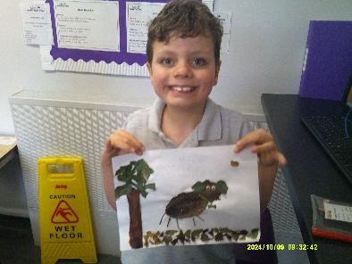

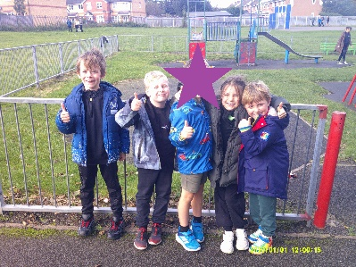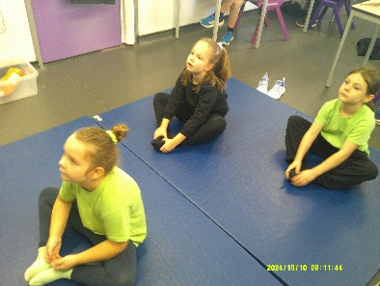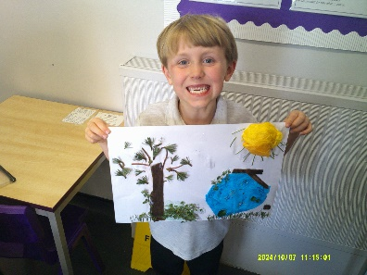Class Sow have enjoyed our diversity days this half term. Pupils have learned about democracy and why it is important, Noah said “It is important that we all have a vote so that it is fair.” Following this, Class Sow have started to complete a daily vote to decide our book to be read each morning in class. Pupils enjoyed learning about different habitats on ‘World Habitat Day’ and used natural materials to create a habitat for an animal of their choice. On ‘World Mental Health Day,’ pupils discussed the importance of mental health and took part in a range of activities to promote this, including; yoga, walking, sensory experiences and even a trip to our local park. Pupils enjoyed the day and Charlie said, “Our brain needs to relax to stay healthy and this was the best day ever!”

**Class Severn**

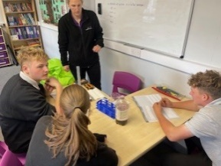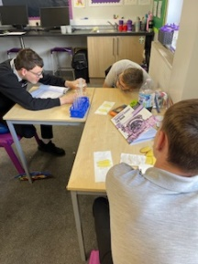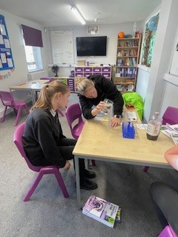In Science lessons during the Autumn Term the class have enjoyed studying health and disease, and plants and ecosystems. A lesson the class especially enjoyed was an experiment to test osmosis through potatoes, the class made their predictions prior to completing the experiment following the correct protocols. As a class they made some excellent predictions which were backed up by their experiment results.

**Class Penk**

Class Penk have enjoyed geography this half term. The topic they have been focusing on is Benin Africa! Class Penk have been able to identify the features of a rainforest and were able to show an understanding of where ‘Benin’ came from and developed into. Class Penk have also enjoyed learning about Benin’s trade and currency! Students were able to identify how trade was introduced and carried out. Class Penk had lots of fun using their skills to highlight trade routes on a map. They engaged in discussion regarding how people travelled and the currency which was used during trading. Oliver especially enjoyed looking at a ’cowrie shell’!

**Class Waldron**

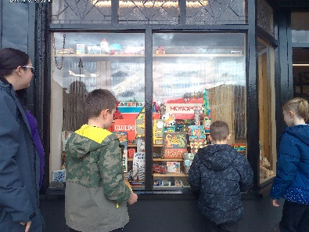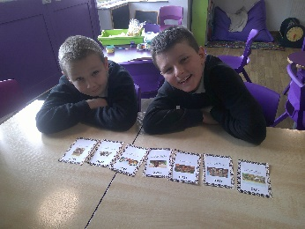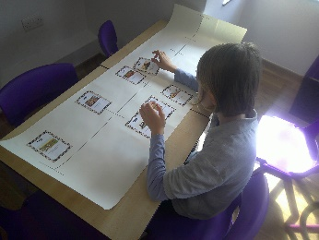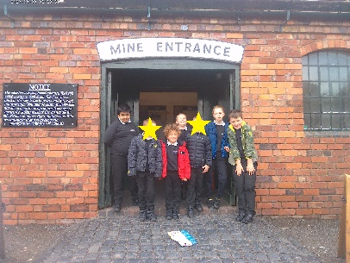Class Waldron have been learning all about the Kingdom of Benin in history this half term. They began by creating a timeline of the country’s history, using figures to recreate key events such as the crowning of the first Oba and the British invasion. Pupils were able to identify features of a Benin plaque and interpret what it teaches us about Obas in Benin, before role-playing the ruler and his followers. B demonstrated great understanding when he described an Oba as a “strong and powerful king, who protects and owns the land”. To further understand how historians learn history, the class visited the Black Country Museum. They had a fantastic time immersing themselves in the past and were able to observe a range of different sources that teach us about history.

**Class Manifold**

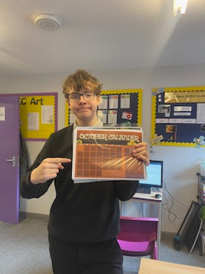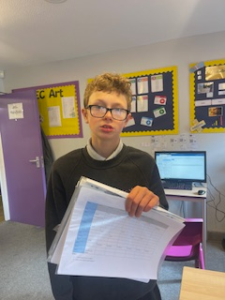Class Manifold have enjoyed BTEC ICT this half term. They began to develop key techniques to help organise their work and prioritise and manage their time effectively. A highlight was creating a personalised weekly calendar. Bailey said, "I got to use [the software] scratch in lesson, I love using this." Daniel decided to use word to create his calendar, he enjoyed inputting his weekly schedule. Students then went on to explore and review various techniques to improve their own organisational skills. Students were able to set up and manage a filing system of work, to allow for quick and easy access. All students in class Manifold have shown a great improvement in the basic use of IT software.

**Class Dove – KS3**

Pupils in KS3 in Class Dove have been learning how to create and edit their own pictures using software on the PC. In their most recent lesson, they picked a picture of a football player and began to edit their own Bitmap image. They then added this to a background on their design. H said that ‘This has been really difficult, but I’ve really enjoyed the lesson.’ Well done Dove!

**Class Dove KS2**

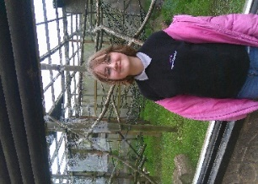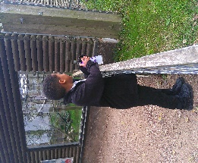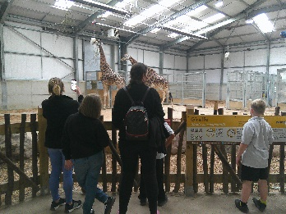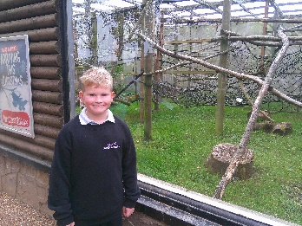Class Dove KS2 have enjoyed English this half term. During this term we have been focusing on non- fiction persuasive writing on animals in captivity. In their topic, students developed their ability to create their own independent letter by planning, writing and evaluating. The children had the opportunity to visit a local zoo to research information, to allow them to write a letter expressing their own views and opinions. “I think zoos are good and bad because they have a secure home, but they don’t get to be free. R discussed with his peers. Over several lessons the children really engaged and worked well with staff to create their own individual opinionated letter to the zookeeper. The children also shared their amazing letters to each other and were respectful of each other’s reasons.

**Class Dane**

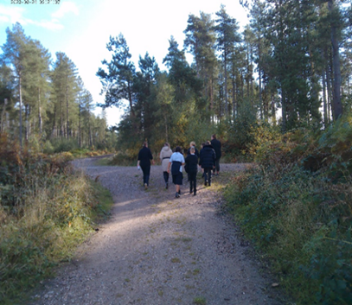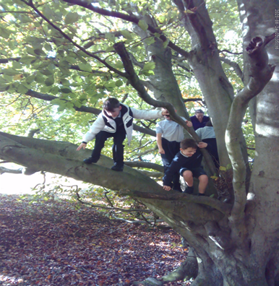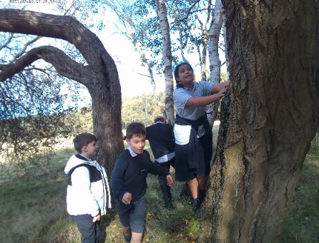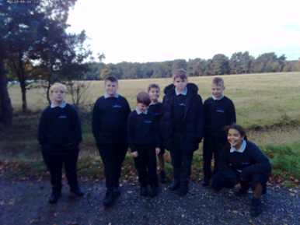In recognition of World Mental Health Day, Class Dane spent the day at Cannock Chase, enjoying the benefits of being outside and getting close to nature. Students enjoyed the opportunity to chat with each other as they walked along and it was lovely to see different peer relationships forming as the children discovered more about their common interests. Whilst there, Class Dane were presented with the opportunity to check off another Heather Field 50 – ‘Climb a Tree’ and had great fun seeing how high they could get. The morning finished with free time on the park before sitting down together for a picnic lunch and a chat about how fantastic the day had been. Anavara declared “This has been awesome, even better than reward day!”

**Class Blithe**

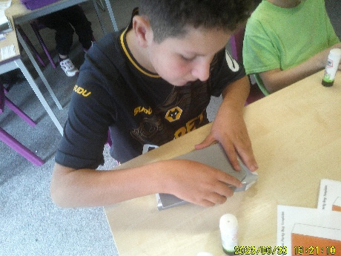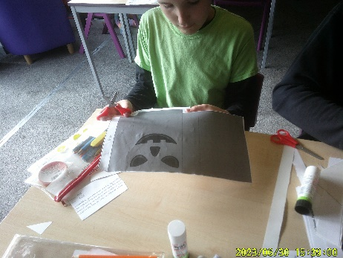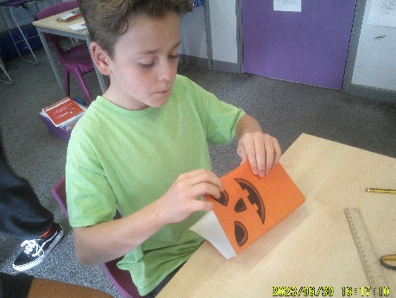Class Blithe have enjoyed some practical lessons in Design and Technology this half term. They have been exploring the production of carrying devices and first evaluated the effectiveness of different types of carrier bags before learning how to create their own. A particular highlight was Ella who enjoyed making a carrier bag ready for Halloween. The class worked hard on improving their skills to measure, mark out, cut, score and assemble a net before finishing off their spooky designs ready to take home for the half term holiday. Dylan was particularly happy with his final product after paying great attention to detail.

**Class Meese**

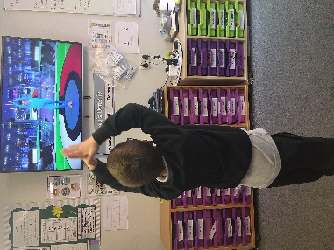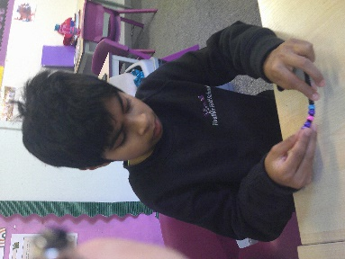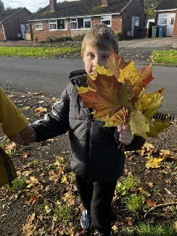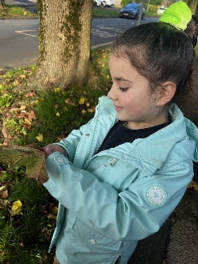To celebrate World Mental Health Day, Class Meese enjoyed a relaxing morning walk around our local area! The children connected with their surroundings by using some of their senses on the walk to identify things they could see, hear and touch. Max said “This walk is amazing!”, whilst Rishi said the walk made him feel “Really good”. Throughout the day, the children took part in several different mindful activities such as yoga, and particularly enjoyed making breathing wands. Well done, Class Meese!

**Class Stour**

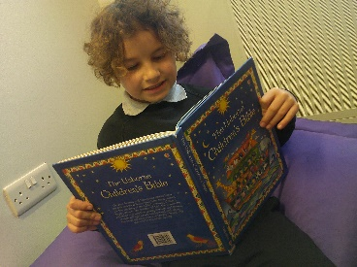In RE, Stour KS1 have been exploring The Creation Story. They sat as a group and read The Creation Story, before using play-doh to mould their very own people! They enjoyed talking about how some people believe that God made all aspects of nature and then went on a beautiful nature walk to explore the leaves, trees and flowers. Amelie said ‘These flowers are beautiful’ whilst exploring the different coloured flowers.   
KS2 have been exploring Christianity, specifically understanding the importance of The Bible to Christians. They all recognised that some religions have a ‘special book’ and they enjoyed exploring some stories from The Bible. The children also enjoyed visiting the local library to explore a variety of special books, including different religious texts.

**Class Trent**

Class Trent have enjoyed music this half term. They began studying American Folk music and a highlight was using computer software to create their own songs. Ronnie said “I love this sort of music, can I make up lyrics?” They then went on learn about Jazz music. Also in September, Shay earned the musician of the month award!

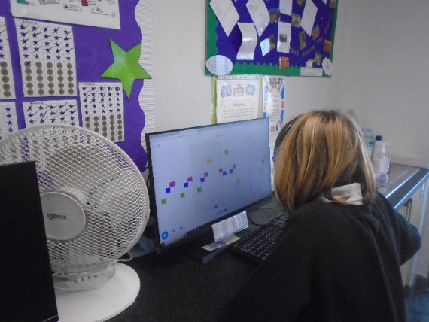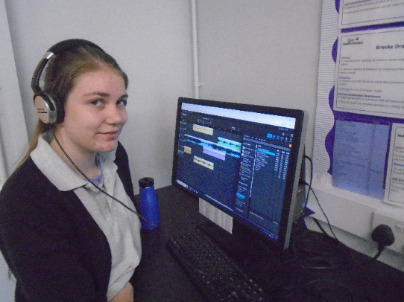

**Class Churnet**

Class Churnet have enjoyed science this half term. They began studying nutrition and a highlight was carrying out an experiment to explore the human digestive system and seeing how the intestines create poo. Thomas said, “Errr, thats disgusting but so cool, our intestine does that!” They then went on to learn about plants and how they reproduce. As part of their plant topic, Churnet enjoyed revamping a local care home’s garden area after asking for donations from our community and using their knowledge of plants.

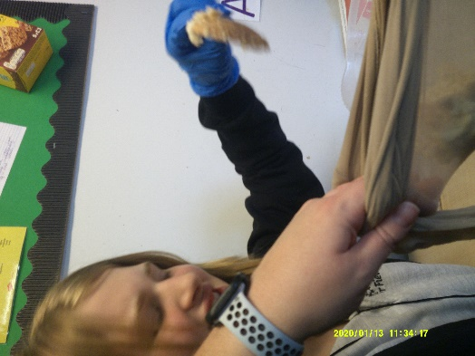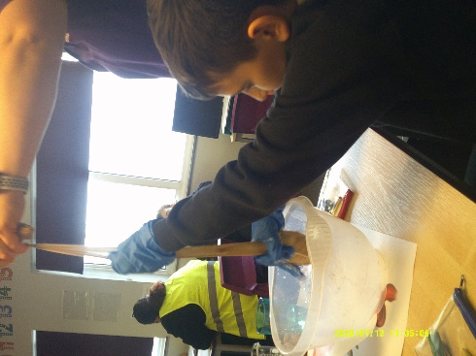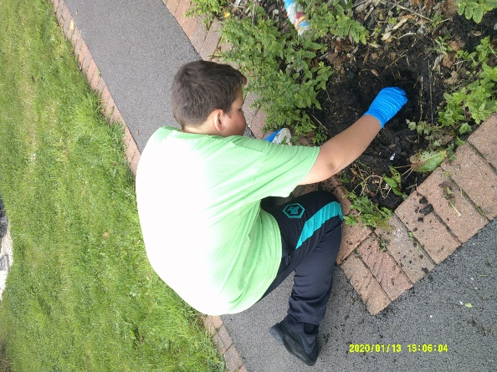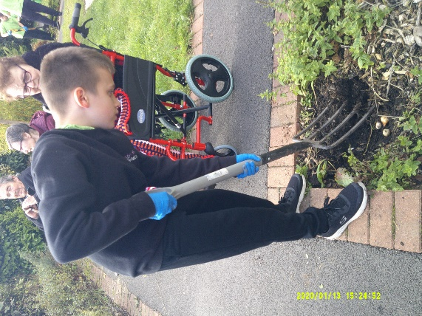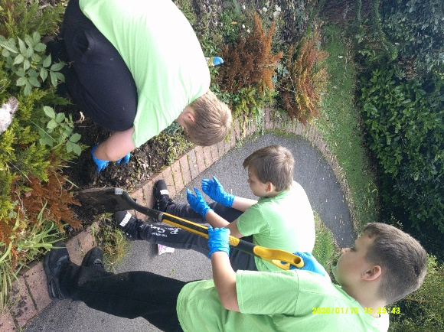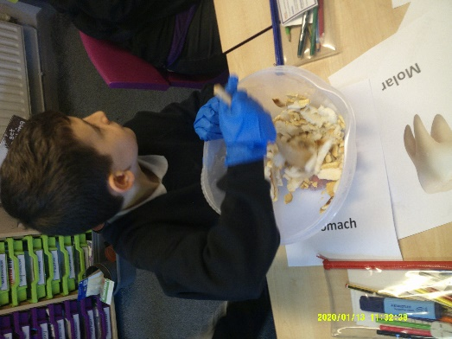

Have a wonderful Half Term Break

We look forward to welcoming the pupils back in school on Monday 4th November 2024